**LAB # 01 and 02**



**Spring 2019**

**CSE102L Computer Programming Lab**

Submitted by: **Haris Khan**

Registration No. : **60032**

Class Section: **A**

“On my honor, as student of University of Engineering and Technology, I have neither given nor received unauthorized assistance on this academic work.”

Student Signature: ______________

Submitted to:

**Engr. Abdullah Hamid**

November 24, 2022

Department of Computer Systems Engineering

University of Engineering and Technology, Peshawar

**Q1.** Take a picture of your CPU at home (if you have a laptop, you can take its picture instead). Write down all its specs like what microprocessor (manufacturer, version, generation) does it have, how much ram, storage, connected peripherals/devices etc.

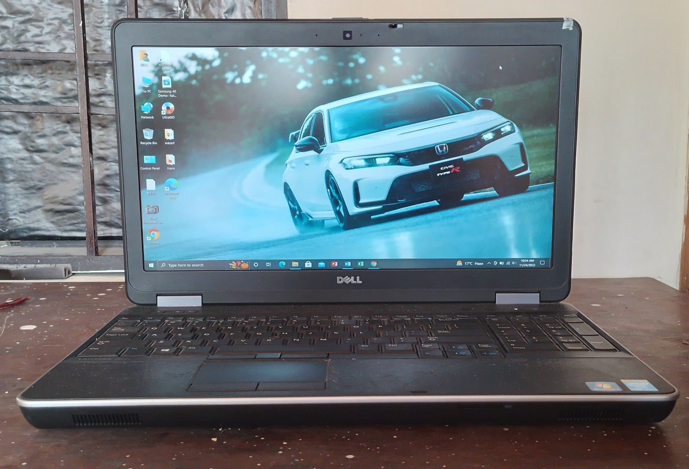

Manufacturer: Dell E6540

Generation: 4th

CPU: Core i7 vPro

RAM: 16 GB

SSD: 256 GB

HDD: 1TB

Clock speed: 2.7 GHz

Chipset: Mobile Intel QM87 Express Chipset

DRAM bus width: 64-bit

Screen: 15.6”

**Connected Peripherals**

* Keyboard: 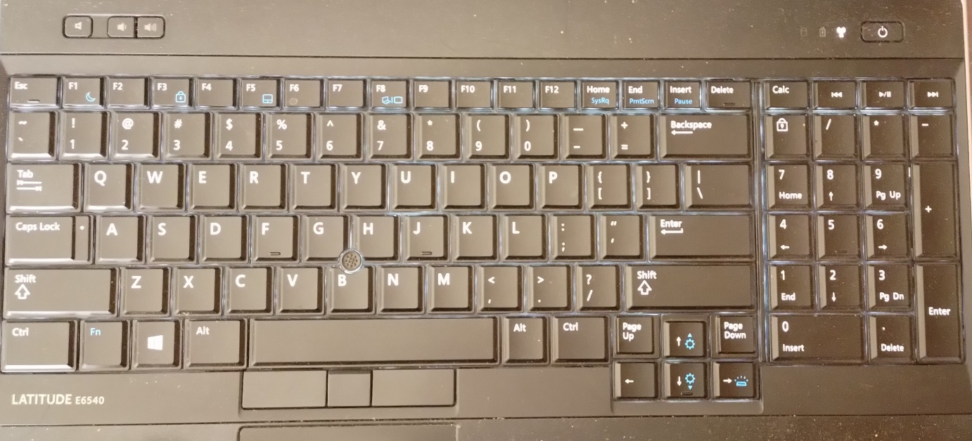
* Track Point:

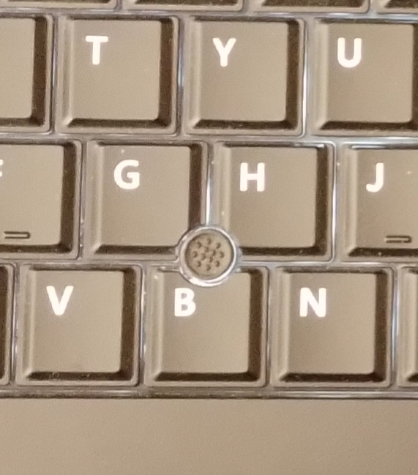

* Touchpad:

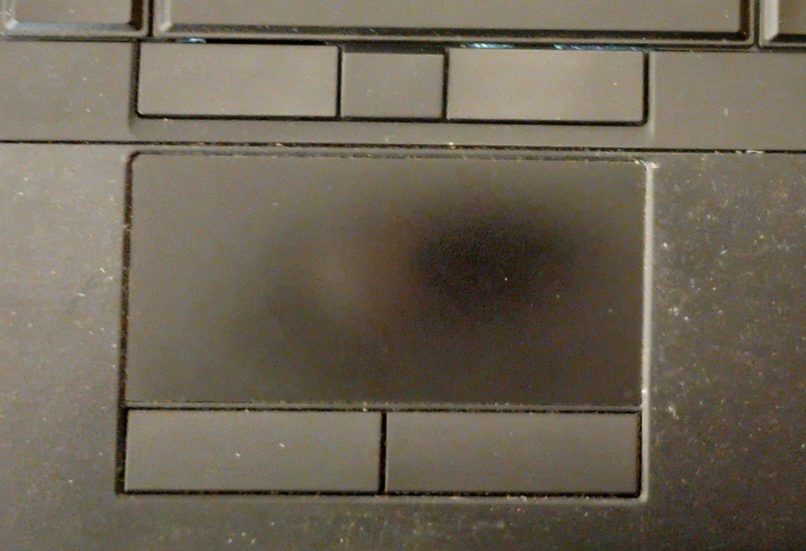

**Q2**. Identify the SOC used in your phone and write its details and specs.

**My Phone:**

**Device Name:** Samsung galaxy A03

**RAM:** 3GB

**Internal storage:** 32GB

**Battery:** Li-Po 5000Mah, non-removable

**Weight**: 196g

**Size**: 6.5 inches

**Main camera:** 48MP (wide), 2MP (depth)

**Selfie camera**: 5MP

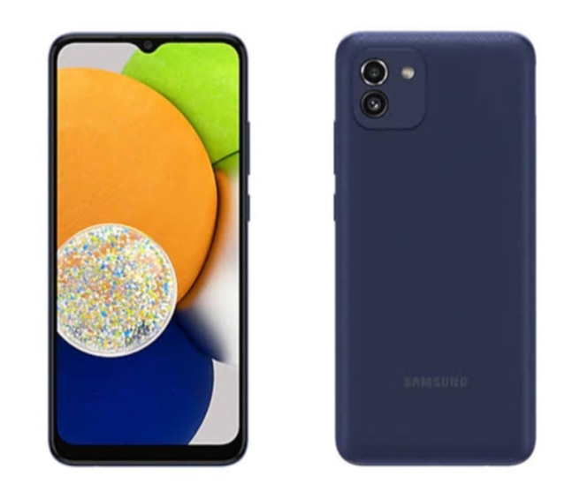

**Q3.** How to install windows OS on a computer? Explain step by step.

1). Go to the Microsoft download windows 10 web page.

2). Click **Download tool now** to download the file MediaCreationTool.exe.

3) Accept the license terms.

4). Select **Create installation media (USB flash drive, DVD, or ISO file) for another PC,** and then click **Next.**

5). Select the language, edition and architecture (64-bit or 32-bit) for the windows 10 installation, and then click **Next.**

6). Insert a blank USB drive, select USB flash drive, and then click next.

7). After the media creation tools finishes writing the windows installation media on USB drive, click **Finish.**